**QUIZ RESULTS**

**MODULE3: CROSS VALIDATION**

|  |  |  |  |  |
| --- | --- | --- | --- | --- |
| **No.** | **Quiz title** | **Completion Status** | **Score** | **Coursera link** |
| 1 | Module3_Practice Quiz_ Cross Validation | Completed | 100% | [Quiz 1](https://www.coursera.org/learn/supervised-machine-learning-regression/assignment-submission/oTG5v/practice-quiz-cross-validation) |
| 2 | Module3_Cross Validation | Completed | 100% | [Quiz 2](https://www.coursera.org/learn/supervised-machine-learning-regression/assignment-submission/QU4QP/graded-module-3-quiz-cross-validation) |

# Module3_Practice Quiz_ Cross Validation

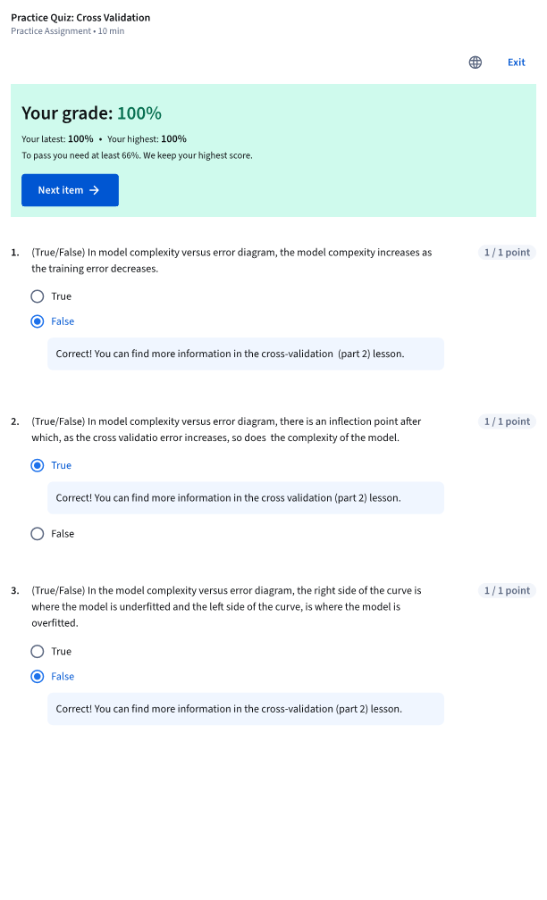

# Module3_Cross Validation

